Pancyprian Union of Chemists  Division of Quality Assurance  Eurachem Cyprus Committee | 

Laboratory Accreditation
A Two-Day Training Workshop

RECENT DEVELOPMENTS IN QUALITY ASSURANCE

12-13 March 2024 Cleopatra Hotel, Nicosia, Cyprus
Conference Room Macedonia

Introduction
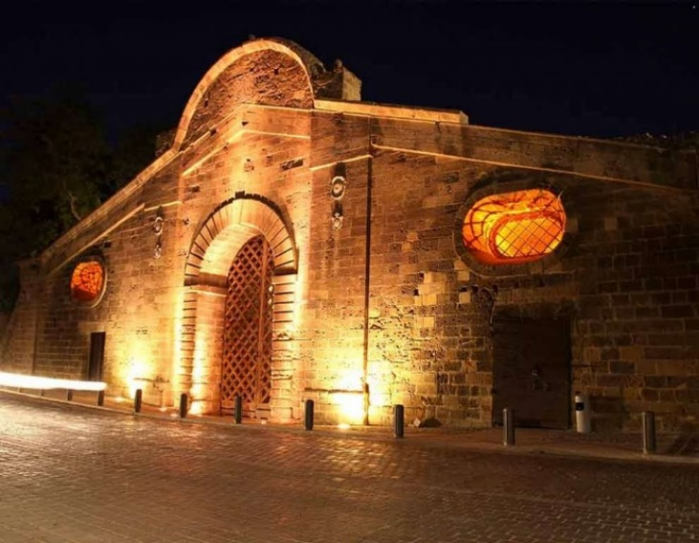
Following a number of successful training events, most recently on the revised ISO 15189 standard, the Pancyprian Union of Chemists (PUC) and the Eurachem Education and Training Working Group are organising a two-day workshop on quality assurance in Nicosia in early March 2024. The programme is based around the main sections of the recently revised Eurachem Guide on Terminology in Analytical Measurement. The workshop will include sessions on terminology, validation, metrological traceability, internal quality control, external quality assurance (with emphasis on the new ISO/IEC 17043 standard) and quality assurance in qualitative analysis. The programme will also include an overview of publications on quality assurance, with an emphasis on recent revisions of Eurachem guides. Participants are invited to share experiences in their laboratories via short oral presentations and a poster session.

The scope of the training is to
- Present and discuss critical issues of interest to both analytical and medical laboratories addressed in ISO/IEC 17025:2017 and ISO 15189:2022 respectively, as well as other relevant documents;
- Discuss the experience of laboratories in various sectors, problems and solutions;
- Present recent publications (Eurachem guides and others).

How to meet the task
This task will be addressed through presentations by experienced trainers, exercises and group work. It is expected that on completion of the training, participants will have a good understanding of the critical issues addressed in both accreditation standards and will acquire a clear picture of the work to be done in their organisations. The training will be delivered by tutors that have been actively involved for many years in Eurachem activities and its Working Groups and/or the Executive Committee.

Who can participate?
The training is oriented to
- Personnel of accredited analytical and medical laboratories as well as those preparing for accreditation;
- Lead assessors/assessors/technical experts;
- Consultants.

Certificates of participation will be issued to participants who attend fully.

Posters and short presentations
Abstracts for posters (up to 300 words) should be submitted by 16 February 2024. Those who intend to give a short presentation of their experience, problems and solutions shall inform the organisers by the end of February 2024, indicating the relevant topics.

The language
The training will be carried out in English.

The fee
For the two-day workshop the training fee is €250 for those register by 16 February 2024. After that date, the fee will be €300.
If more than one participant from the same laboratory/organization attends, the fee will be €225 and €270 respectively for the additional participants.
The fee covers the training material, refreshments and lunches as well as dinner on the first day.

For those coming from abroad
Accommodation
The training will be hosted at the Cleopatra Hotel, a 4-star hotel in the centre of Nicosia (www.cleopatra.com.cy). A number of rooms have been pre-booked at the hotel (valid until 2 February 2024).
Room Rates | Standard | Executive
Single Room B/B | €115.00 | €130.00
Twin Room B/B | €140.00 | €155.00

The above rates are per room per night inclusive of buffet breakfast, taxes and service, and free internet.
Payment Terms: To confirm a reservation the hotel will request prepayment.
Cancellation Policy: If a reservation is cancelled less than 72 hours before arrival date or in case of No Show a one night cancellation fee will apply.
Participants will need to make their own reservation directly with the hotel.
Email: info@cleopatra.com.cy, tel. +357 22844000 with reference to the code PUC 2024.

Visa requirements
Participants from third countries (not member states of the European Union) may need to obtain a visa. Relevant information appears under visa policy on the website of the Ministry of Foreign Affairs of the Republic of Cyprus (www.mfa.gov.cy). To this end participants should contact the local organisers for an invitation letter to be provided in time.
Entrance to Cyprus
Only via the legal airports of the Republic of Cyprus, namely Larnaca and Pafos International Airports. Larnaca is the preferred airport, as Pafos is further from Nicosia (extra 1 hour transfer time).

Transportation to/from the hotel
Upon arrival at Larnaca International Airport, participants may catch
- EITHER, the shuttle to Nicosia terminal (for timetable, visit https://www.kapnosairportshuttle.com); the fee is €9. The shuttle could continue to the hotel at an additional cost of €9 – use the code PUC 2024)
- OR a taxi directly to the hotel; this will not cost more than 55 €.

For information, contact…
qualityassurancepuc@gmail.com/kctsimillis@cytanet.com.cy/despinacharalambous@yahoo.co.uk

The trainers...
Vicki Barwick  After studying chemistry at the University of Nottingham, Vicki joined LGC in 1990 as an analytical chemist. She then worked on projects funded by the UK government’s Valid Analytical Measurement (VAM) programme, focusing on the development of approaches to evaluating measurement uncertainty in chemical analysis. This work led to the development of training courses on uncertainty evaluation and wider quality assurance issues. Vicki is currently the Head of Commercial Training at LGC and has over 25 years’ experience in the development and delivery of training courses in the area of analytical quality assurance. She has produced a wide range of training materials and is co-author of the books ‘Quality assurance in analytical chemistry’ and ‘Practical statistics for the analytical scientist’. She is the Past-Chair of the Eurachem network and Chair of the Eurachem Education and Training Working Group. | 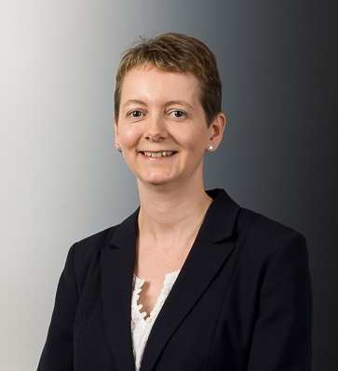
Brian Brookman  Brian Brookman, formerly the Chief Scientific Officer for LGC’s global PT business, and now working as an independent consultant on proficiency testing, has over 45 years’ experience in analytical science, the past 30 years in the field of analytical quality, particularly concerned with proficiency testing. He has been involved, around the world, in various training and consultative projects concerned with developing proficiency testing and the accreditation of PT providers.  Brian is very active at the national, European and international level with respect to the development and harmonisation of good practice in proficiency testing. He is currently Chair of the ILAC Accreditation Issues Committee 17043 Working Group, Chair of the Eurachem Proficiency Testing Working Group, Chair of the EA-Eurolab-Eurachem (EEE) Joint Working Group on Proficiency Testing in Accreditation and Chair of the UK Working Group on Proficiency Testing. He was an ILAC liaison at the ISO/CASCO Working Group that revised ISO/IEC 17043. | 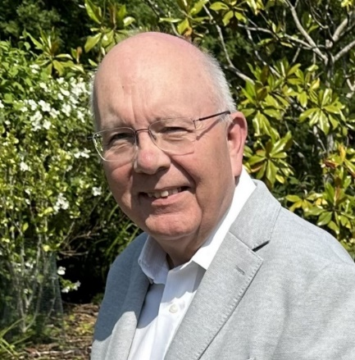
Despina Charalambous  Dr Despina Charalambous studied Chemistry at the University of Cyprus and she continued her studies with an MSc in Molecular Medicine at Imperial College London. She was accepted at the University of Cyprus at the Department of Biological Sciences for her PhD in Molecular Biology. She worked as a Lab Manager in private accredited laboratories in Nicosia. Since 2013, Dr Charalambous is working as a Lecturer in the Department of Pharmacy at Frederick University. She teaches the undergraduate courses of Food Chemistry and Nutritional Analysis, Molecular Biology and Pharmaceutical Biotechnology as well as the lab courses Molecular Biology, Microbiology, Food Chemistry and Nutritional Analysis, Pharmaceutical Biotechnology and Biochemistry. Dr Charalambous’s research interests focus on neurodegenerative diseases and the role of pharmaceutical agents in the progress of the diseases, including natural products. She is a member of the Pancyprian Union of Chemists and the Society of Biological Sciences. Since 2016, she is an external collaborator of CYS (Lead Assessor for ISO 15189:2022 and ISO/IEC 17025:2017). | 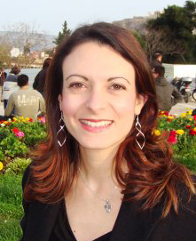
Steve Ellison  Dr Ellison is a Science Fellow at LGC, the UK National Measurement Laboratory for chemical and biological measurement. Originally qualified as a chemist, his current interests are primarily in statistics, measurement uncertainty and reference material certification. He is a co-author of Eurachem guides on measurement uncertainty, metrological traceability and qualitative analysis and contributes to a range of IUPAC, ISO, CEN, BSI and other committees involving applications of statistics for measurement. He also currently chairs the Eurachem Working Group on Measurement Uncertainty and Traceability. | 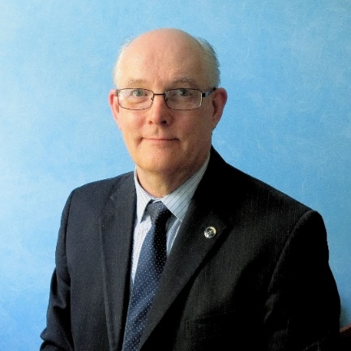
Marios Kostakis  Dr Marios Kostakis studied Chemistry at the National and Kapodistrian University of Athens and he continued his studies with MSc Chemical Analysis – Quality Control at Laboratory of Analytical Chemistry of National and Kapodistrian University of Athens. He received a PhD in Chemistry at the same University with title: “Development methods for determination and identification chemical indices for food freshness with mass spectrometry techniques”. Since 2017 he has worked as quality assurance manager in the Service Laboratory of Chemical Analysis – Quality Control under the supervision of the academic laboratory of Analytical Chemistry. Since 2019, he has been a member of the Eurachem Method Validation Working Group and the Joint Task Group on Validation of Measurement Procedures that include sampling. Since 2020, he has worked as a teaching fellow in undergraduate and postgraduate courses such as ISO 17025 quality assurance system, Advanced Analytical Techniques, Instrumental Analysis II (Spectrometry & Chromatography), Food Safety and Quality Control, Practical’s of Analytical Chemistry, and Spectrometry Techniques. He is a member of Association of Greek Chemists and a member of its Scientific Committee of Analytical Chemistry. | 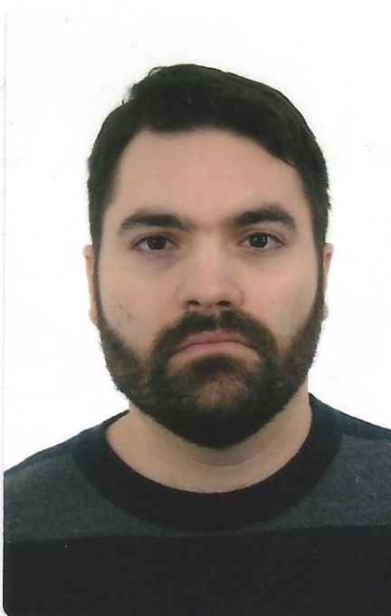
Bertil Magnusson  Bertil started as a marine chemist looking for traces of metals in sea and fresh water in the 70's. At that time clean room and clean sampling was something totally new. After his PhD he joined a chemical company, AKZO-NOBEL as a specialist in analytical chemistry mainly with atomic spectroscopy (XRF, AAS, ICP), XRD and wet chemistry. His work supported the laboratories in Europe and America.  In the 00’s he joined the Swedish Metrological Institute, RISE representing Sweden in metrology (CCQM, Euramet and Eurachem) and performed mainly inorganic analyses. Bertil is now a consultant in analytical chemistry – see www.trollboken.se.  A major part of his work which he likes a lot is teaching and taking part in writing Nordtest and Eurachem guidelines in quality of measurement, e.g. accreditation, quality control, validation, measurement uncertainty and decision making. | 
Kyriacos Tsimillis
Kyriacos holds a BSc and a PhD in Chemistry (University of Athens - 1971, 1977). Postgraduate studies at the Nuclear Research Center “Demokritos” (1972-1975). Lecturer at the Physical Chemistry Department of the University of Athens (1975-1980), he was involved in standardization and certification activities in Cyprus for twenty years followed by twelve years in accreditation until his retirement (December 2013). He was the Coordinator (2005) and as from 2009 the Director of the Cyprus Accreditation Body (CYS-CYSAB). He represented CYS-CYSAB in EA and was a member of peer evaluation teams of EA (2013-2014). Since 1997 he represents the Pancyprian Union of Chemists in Eurachem, including a two-year period as its Chair (2008-2010) and for many years as a member of the Executive Committee; he also represented Cyprus in Eurolab and the Euromed Quality Programme. He is the author of research papers and a co-author in books on Quality. He was an invited speaker in seminars, workshops and conferences. He organized a lot of training activities and awareness events. Since 2014 he is a member of the Division of Quality Assurance of the PUC.

